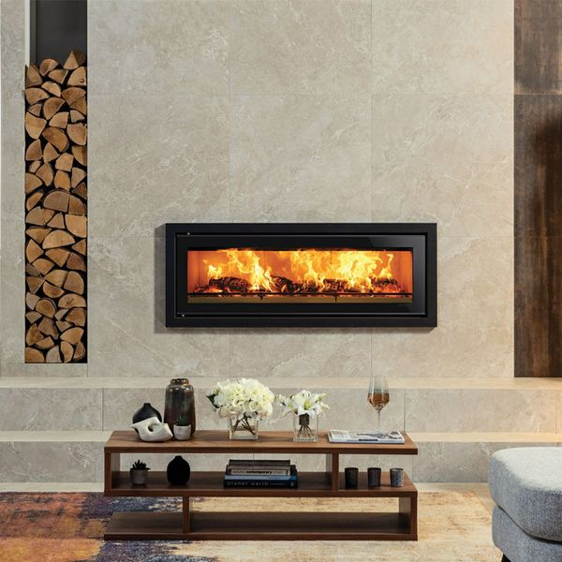**Placid Marble Effect Tiles:**

## **Product Description**

Alive with strong veining, these Boketto Placid Marble Effect Tiles have multiple variations to help give the naturalistic variance offered by natural marble. They consist of a cream and beige background and have a soft matt finish, which is perfect for creating a tranquil backdrop. They're made from durable porcelain, so they're long-lasting and hard-wearing.

## **Product Info**

* Product ID: 40281
* Tiles Per SQM: 1.7777777777778
* Sale by: Per SQM
* Size: 750x750x11mm
* Weight: 14.33 KG
* Material Type: Porcelain
* Finish: Matt
* Colour: Beige/Ivory
* Suitability: Floors, Walls
* Grade: 4?
* Rectified Edge: Yes
* Underfloor Heating: Yes
* Thickness (mm): 11